User ManualFor Electronic Submission of QRTs (xbrl instance files) to ICCS

**EIOPA SOVENCY II**



1. Login to XBRL Submission System
   1. Access the following link: <https://iccs.mof.gov.cy/xbrl/>
   2. Enter username and password (see Figure 1):

In order to login into the system so as to proceed with the submission of the QRTs (xbrl instance file), each undertaking needs to use the username it has used in the past in order to submit Annual Returns electronically into our system. The password is the same with the addition of a “!”.

For example, if the username for the submission of annual returns was testinsurance, and the password was abcde90, the new password for the QRTs submission will be abcde90!.

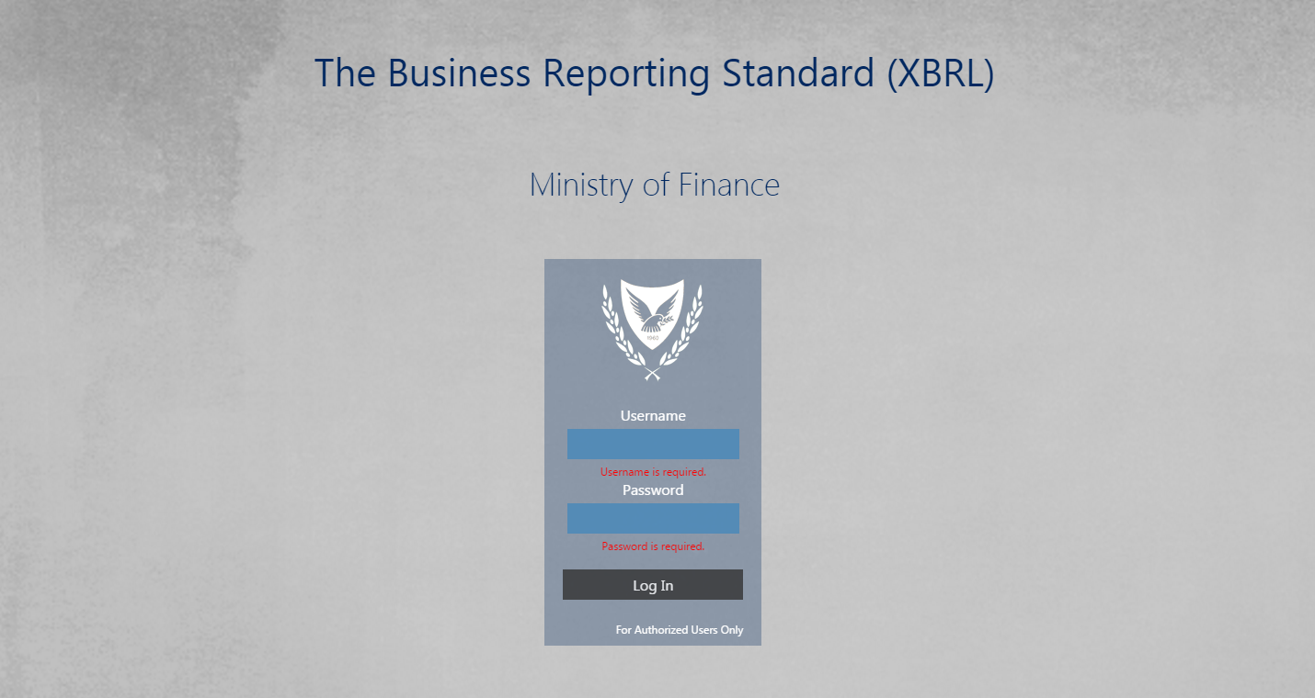 Figure 1-Login Page

2.Submission of QRTs (xbrl instance file) into XBRL Submission System

* 1. If login is successful the undertaking needs to follow the following steps:

<<Login>>🡪Reports🡪Reports Submission

* 1. The screen below will appear where the user has the ability to view any pending reports that need to be submitted and also any completed submissions.

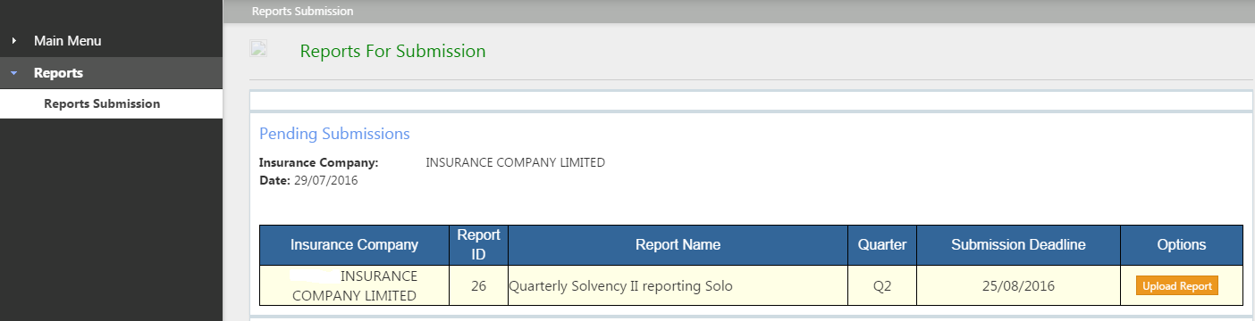Figure 2-Submission Page

**2.3** By selecting <<upload>> apopup window appears which allows the undertaking to select the desired XBRL file and proceed with its upload (see figure 3).Please note that the system will only accept files in xbrl format.

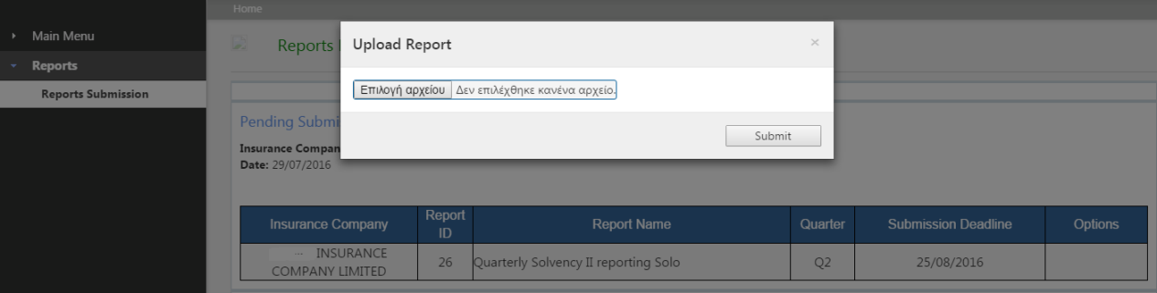Figure 3-Upload Popup Window

**2.4**The submission status of the report is automatically updated after the upload of the xbrl instance file.